Statement and Confirmation of Own Work



***A signed copy of this form must be submitted with every assignment.***

***If the statement is missing your work may not be marked.***

**Student Declaration**

I confirm the following details:

|  |  |
| --- | --- |
| **Student Name:** | Johnson Kenisha Corera |
| **Student ID Number:** | c23020001@cicra.edu.lk |
| **Qualification:** | Bachelor in Cyber Security |
| **Unit:** | SIT325 Advanced Network Security |
| **Centre:** | CICRA Campus |
| **Word Count:** | 532 |
| I have read and understood both *Deakin* *Academic Misconduct Policy* and the *Referencing and Bibliographies* document. To the best of my knowledge my work has been accurately referenced and all sources cited correctly.  I confirm that I have not exceeded the stipulated word limit by more than 10%.  I confirm that this is my own work and that I have not colluded or plagiarized any part of it. | |
| **Candidate Signature:** |  |
| **Date:** | 26/11/2024 |

**Task 1.1P**

**Table of Contents**

* Introduction…………………………………………………….……………………04
* VM Ubuntu Installation…………………………………………….……….……….05
* Ping with Virtual machine…………………………………………..………………..07
* Mininet Installation ……………………………………………….…………………09
* Q&A
* Question A……………………………………………………………………11
* Question B……………………………………………………………………12
* Conclusion……………………………………...…………………………………….13
* Reference……………………………………………………………………………..14

**Table of Figures**

Figure 1………………………………………………………………………………………06

Figure 2………………………………………………………………………………………06

Figure 3………………………………………………………………………………………07

Figure 4………………………………………………………………………………………08

Figure 5………………………………………………………………………………………09

Figure 6………………………………………………………………………………………09

Figure 7………………………………………………………………………………………10

**Table of acronyms**

|  |  |
| --- | --- |
| **Acronym** | **Full Form** |
| DNS | Domain Name System |
| HTTP | Hyper Text Transfer Protocol |
| IP | Internet Protocol |
| LAN | Local Area Network |
| MN | Mininet |
| NAT | Network Address Translation |
| PPCP | Pulse Position Coded Protocol |
| RAM | Random Access Memory |
| SDN | Software Defined Networking |
| TCP/IP | Transmission Control Protocol |
| VM | Virtual Machine |
| VPN | Virtual Private Network |
| WAN | Wide Area Network |

**Introduction**

This post describes how I configured an Ubuntu virtual machine on VMware workstation for the installation of Mininet-a network emulation application. The purpose of this configuration is providing a lab to experiment and advance programmable networks that leverage software-defined networking (SDN). These are: installation of the necessary software; configuration of the Virtual machine and confirmation that Mininet is running as expected.

**VM Ubuntu Installation**

I will create an Ubuntu virtual machine with it; the steps as well as images of my processes are presented below.

* First, I downloaded the Ubuntu ISO file form Ubuntu website.
* In order to establish a new virtual machine, I then launched VMware
* It was called Advance Networking Ubuntu. This was a Linux operating system with the 64-bit version and the system having a 4 GB RAM, two cores and 30GB hard drive created dynamically using the network adapter – NAT.
* The ISO file of Ubuntu was incorporated as a bootable disk to the virtual machine.
* Finally, I started the virtual machine, and then installed the Ubuntu with update manager by going through the instructions on the screen.

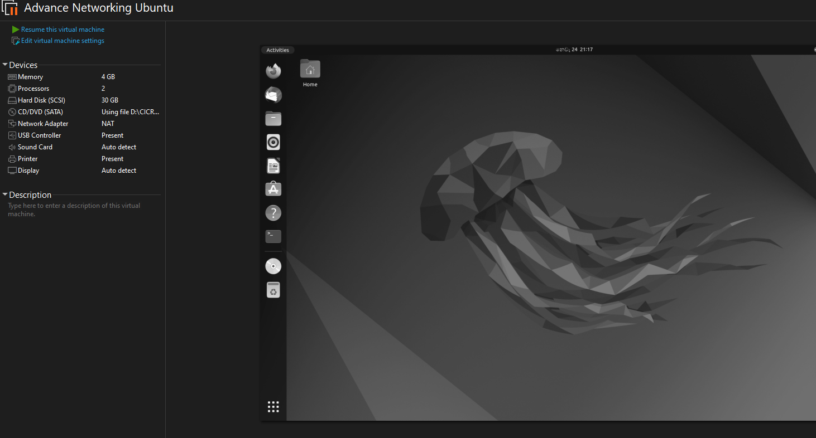

*Figure 1 – Successful Installation*

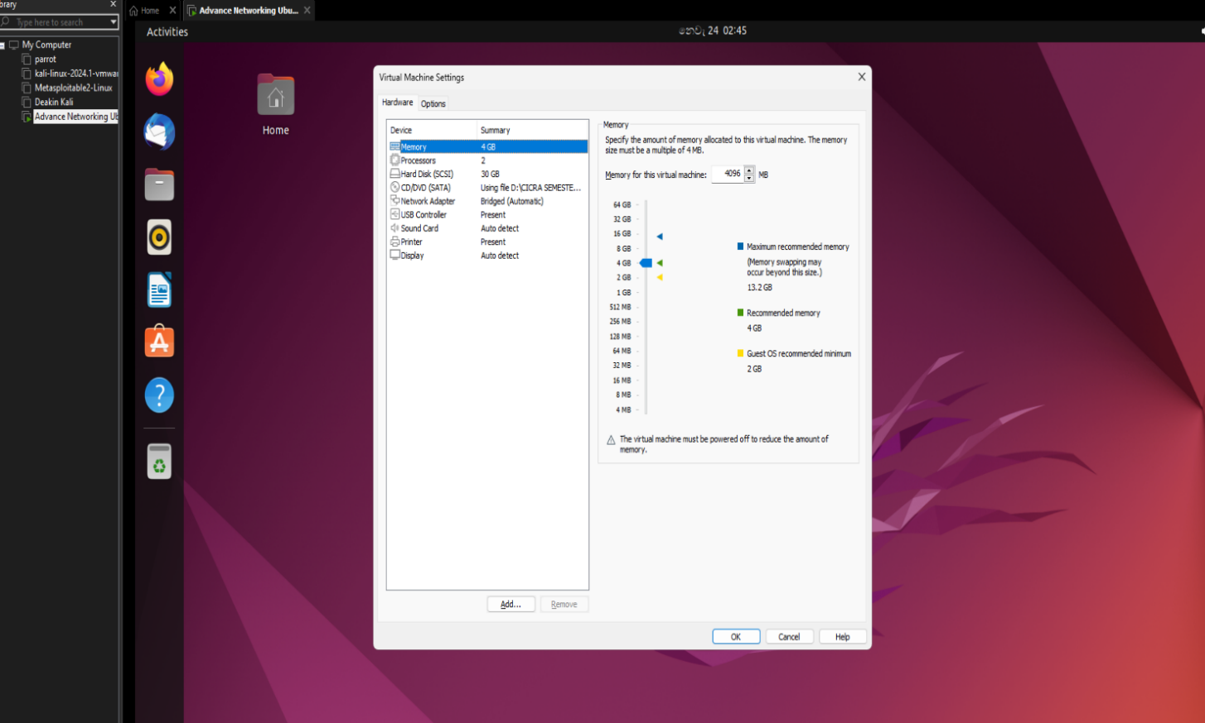

*Figure 2 – Ubuntu VM Settings*

**Ping with Virtual machine**

As it is now, the connectivity of the Ubuntu virtual machines and the host computer must be checked.

* I started the Ubuntu virtual machine first.
* In the Ubuntu terminal I checked the IP address of the system by typing the command ifconfig. Its number was 192.168.232.133. Here is a screen grab of it.

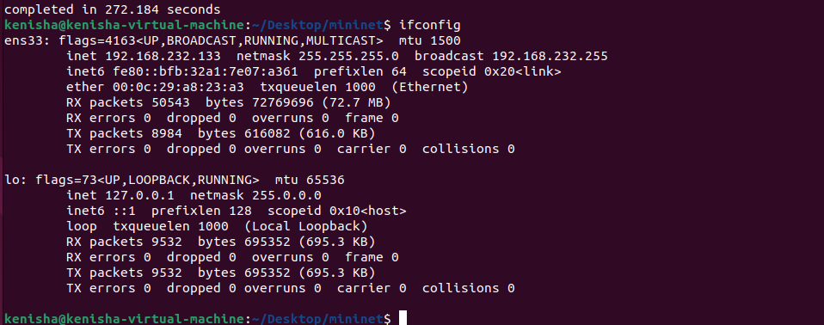

*Figure 3 – Ubuntu VM ip address*

* As a way of confirming if my host was connected to the Ubuntu virtual machine, I went back to my host computer and used the ping command on the Ubuntu machines IP address (ping 192.168.232.133). The host computer on which I conducted the experiment operated Windows 11. This is a screenshot of it.

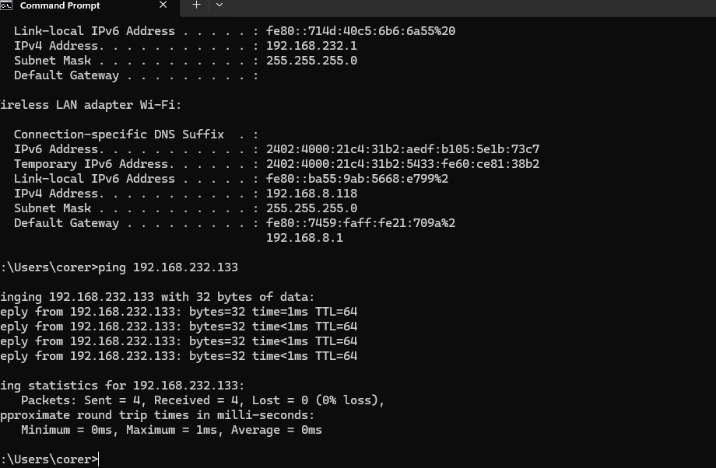

*Figure 4 – Successful Pinging*

* The good ping ensured that there was a positive interaction between the two machines.

**Mininet Installation**

I installed Mininet after confirming the interconnection of the host system with the newly created virtual machine.

* Initially, I launched the terminal in Ubuntu.
* Using the touch command, I first create a folder called mininet
* Used the command “sudo apt update” to update the package list.

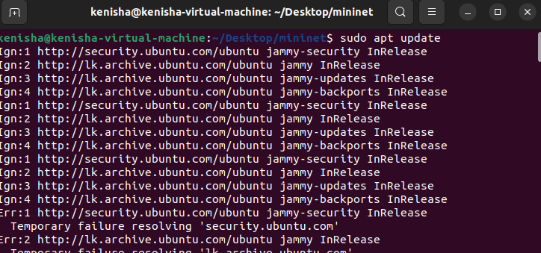

*Figure 5 – Ubuntu updated*

* Next, as instructed in the assignment, I entered the command “sudo apt install mininet” to install mininet.

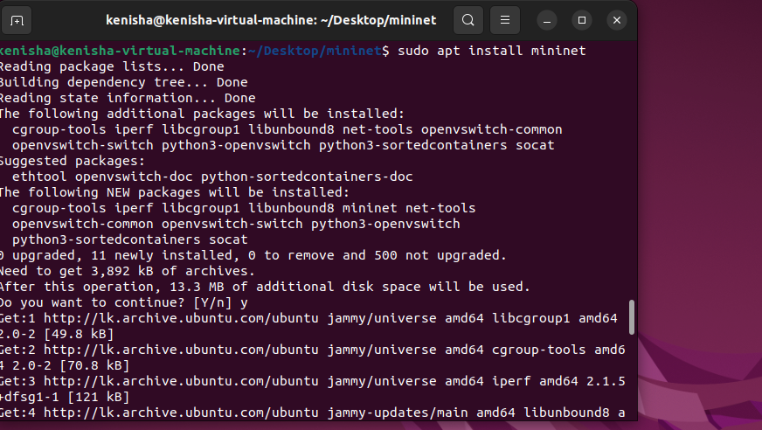

*Figure 6 – Installing mininet*

* In order to begin using Mininet I keyed in the command “sudo mn” to start the Mininet emulator with minimum topology which consists of a switch connected to two hosts.

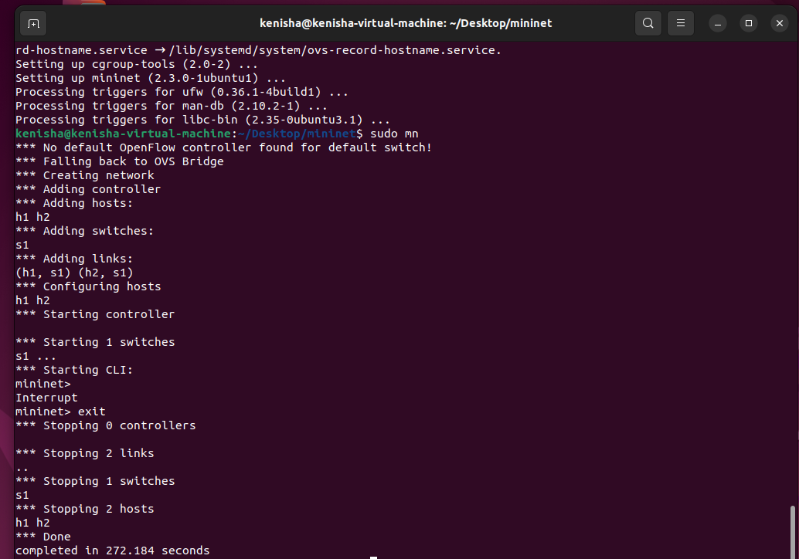

*Figure 7 – Creating Network Topology*

**Answer the following questions.**

**Question A**

1. **In your opinion what is the difference between computer networks and network security? Elaborate your answer in no more than 250 words.**

* Network security and computer networks are two related fields that are critically important to modern information technology infrastructures. Connectivity comes from computer networks but since there is always risk and vulnerabilities in existence, network security is there to safeguard this connectivity. (Myers, 2011)
* Computer networks are systems of interconnected computers, communicating devices, TCP/IP infrastructure, and other peripherals such as servers, switches, routers etc. Depending on their size and coverage they are generally regarded as the Internet, WANs or LANs. PPCP, DNS and HTTP are categorized in protocols in which networks employ to regulate other devices’ data transfer. They tend to focus on side functionality such as being effective, measurable and reliable in supporting programs such as files, emailing and web browsing. The idea of a computer network is that regardless of whether users are in the same building in the same office or in different parts of the world, interconnectivity should be seamless.
* On the other hand, network security is involved with protecting these networks’ systems and data against intrusions, breaches and attacks. With reference to protection provided to the network’s infrastructure, it involves installation of technologies such as intrusion detection/prevention systems, firewalls and antivirus. VPN, encryptions, secure authentications etc. all ensure that the individual’s private information remains ‘private’. In addition to dwellers, Regulations and Protocols also form part of the network security since they help regulate behaviors and expose weaknesses.

(231 Words)

**Question B**

1. **What is the difference between Emulator Testing and Real Device Testing? Elaborate your answer in no more than 250 words.**

* Let me clarify that emulator testing, and real device testing are two testing approaches out there in mobile application testing each of which has its function and serves a particular purpose in testing. (STALLINGS, 2008)
* Emulator testing is the use of software to emulate actual devices in an effort to measure their behavior. Sometimes emulators are used right at the start of the application development process because they are cheap and easy to run. They can run the application on emulators without having the actual devices and can test the application on various operating system versions, resolutions of display possible configurations not possible with normal physical devices. The primary use of emulators is in checking the functionality and unadulterated use – barebone user interactions because of special features such as log tracking, error detection, and breakpoints. In particular, they work faster while doing repetitive functions such as running scripts. But as for the emulation, it is constrained in a way that it cannot fully mimic real conditions, including power management, network conditions, and the hardware specifics of the device in question (cameras, sensors, and fingerprint readers). That is why they are less effective for the assessment of user experience as well as for performance testing. (Tanenbaum, 2013)
* On the other hand, real device testing involves the use real gadgets to test the applications under test. As a result of the real condition, it means hardware behavior, system compatibility, network fluctuations, touch sensitivity, gestures, etc., this method only provides the best result. However, in an effort to establish the functionality of the app as well as the reliability and response time where and when the end user would apply the application, actual device testing is required. But, in contrast to emulation testing, it consumes both time and a significant amount of money to have diverse devices under the test.

(305 Words)

**Conclusion**

* In conclusion, this study provided a step by step guide to creating Mininet through VMware on an Ubuntu based virtual machine. These include installation of necessary software, checking the Mininet settings as directed and checking on the connectivity in the network. Each of the steps in the program was shown with pictures, which meant that everyone who was following the sites described in the text, not only read but understood the content and were able to get the information they needed. This instructions enable users to assess and instantiate Mininet conveniently in their emulation environment.
* The questions posed in the enquiries delineated new characteristics in program building and computer science. This provided us with first glimpse of difference between the computer networks and network security and where network security stands on the spectrum: networks act as a connection while security protects from connections. In a digital environment, however, both components are of equal significance due to this special double focus: On the one hand, it is possible for devices to exchange information with each other behind the user’s back.
* Lastly, in software validation we also looked at the conflicting ideas of emulator testing and real device testing. Even though the emulator testing contributes to the questions of affordability and flexibility it fails to take into account the reality of life. Still, due to the assessment on actual devices which has certainly distinct layouts, Real Device Testing gives a fairer result since it pinpoints the issues which are distinctive to such device and ensures that elements of the app are stable and functional across different scenarios. There can be no doubt as to the fact that these tests are indispensable since they create the possibilities for the establishment of stable and accessible software tools that can be utilized against the connected enemy of today.

**References**

The art of software testing (no date b). <https://books.google.lk/books?id=GjyEFPkMCwcC&printsec=frontcover&source=gbs_ge_summary_r&cad=0#v=onepage&q&f=false>.

Stallings, W. et al. (2016) Foundations of modern networking: SDN, NFV, QOE, IoT, and cloud. Pearson Education, Inc. <https://ptgmedia.pearsoncmg.com/images/9780134175393/samplepages/9780134175393.pdf>.

Computer networks.

<https://books.google.lk/books/about/Computer_Networks.html?id=w_d5ngEACAAJ&redir_esc=y>.